1. Introduction Questions to answer yourself:
- What is this system? (1 paragraph, plain English)
This system is a web-based university timetable optimization platform that helps create, manage, and improve class schedules for teachers, students, rooms, and courses. It automatically generates timetables by following important rules such as teacher availability, room capacity, class conflicts, holidays, and student sections, while also considering preferences like reducing travel between classes, saving electricity, ending classes earlier, and making timetable changes with minimum disturbance.Who is it for?
- What problem does it solve right now?
It solves the problem of manually creating university timetables, which is time-consuming, error-prone, and difficult when there are many teachers, classes, rooms, holidays, and restrictions. The system helps avoid clashes, uses rooms properly, respects teacher availability, and makes timetable changes easier without disturbing the whole schedule.
- What is explicitly not in scope?
Explicitly not in scope are exam timetabling, bus or transport route management, hostel scheduling, individual personalized timetables for every student, attendance management, fee management, full university ERP features, and advanced AI prediction. The system will focus only on generating, managing, and adjusting weekly class timetables for teachers, rooms, courses, and student sections.
2. Overall Description
- What are the main features? (just a bullet list for now)
• Manage teachers, courses, rooms, sections, and time slots
• Add holidays and unavailable days
• Add teacher availability and preferences
• Define hard constraints and soft preferences
• Automatically generate a clash-free timetable
• Check room capacity and room availability
• Reduce teacher, room, and student-section conflicts
• Prefer nearby rooms/classes when selected
• Support energy-saving timetable options
• Support early-ending or morning-class preferences
• Allow manual timetable edits
• Lock fixed classes so they are not changed
• Re-optimize timetable after teacher or room changes
• Show timetable quality, conflicts, and warnings
• Publish timetable for teachers and students
• Export or print the final timetable
- Who are your users and what do they each need?
- • Timetable Administrator
Needs to enter data, define rules, generate timetables, fix clashes, lock important classes, approve changes, and publish the final timetable.
- • Department Coordinator
Needs to manage department-level courses, sections, teachers, and preferences, and review whether the generated timetable is suitable.
- • Teacher
Needs to view their timetable, submit availability or preferences, and request changes if they are unavailable.
- • Student
Needs to view their section timetable clearly and know class time, room, teacher, and day.
- • Facility / Room Manager
Needs to check room usage, room availability, capacity, and whether rooms are being used efficiently.
- • System Administrator
Needs to manage user accounts, roles, permissions, system settings, backups, and basic security.
- What does the system depend on? (internet? a database? other systems?)
The system depends on an internet connection, a web browser, a backend server, and a database to store teachers, courses, rooms, sections, timeslots, holidays, constraints, and generated timetables. It may also depend on university-provided data such as teacher availability, room details, academic calendar, and student section information, but it does not require integration with a full university ERP in the first version.
3. Functional Requirements Format every requirement as: "The system shall [do something]." Write at least 2-3 per use case. Example:
- The system shall allow the Admin to add a new course with a name, assigned teacher, and weekly session count.
- The system shall prevent two classes from being assigned to the same room at the same timeslot.
3. Functional Requirements
UC01 – Maintain Academic Calendar
- The system shall allow the Timetable Administrator to add semester start and end dates.
- The system shall allow the Timetable Administrator to add holidays, blackout dates, and special closure days.
- The system shall prevent classes from being scheduled on holidays or unavailable dates.
UC02 – Manage Master Data
- The system shall allow the Timetable Administrator to add, update, and delete teachers.
- The system shall allow the Timetable Administrator to add, update, and delete courses, sections, rooms, and timeslots.
- The system shall store room details such as room number, capacity, building, floor, and available facilities.
UC03 – Define Constraints and Preferences
- The system shall allow the Timetable Administrator to define hard constraints such as teacher clashes, room clashes, and section clashes.
- The system shall allow the Timetable Administrator to define soft preferences such as early ending, nearby rooms, morning classes, and energy-saving options.
- The system shall allow preferences to be enabled, disabled, or given priority according to university needs.
UC04 – Generate Timetable
- The system shall generate a timetable based on teachers, courses, rooms, sections, timeslots, holidays, and constraints.
- The system shall prevent two teachers, rooms, or student sections from being assigned to conflicting classes at the same time.
- The system shall assign rooms according to class size, room capacity, and room availability.
UC05 – Review Timetable Quality
- The system shall display the generated timetable in a clear weekly view.
- The system shall show conflicts, warnings, and violated preferences in the generated timetable.
- The system shall show timetable quality details such as room usage, teacher load, and number of clashes.
UC06 – Request Teacher or Room Change
- The system shall allow a teacher to submit a timetable change request.
- The system shall allow the Department Coordinator to request changes for teachers, rooms, or class timings.
- The system shall store the reason and status of each change request.
UC07 – Re-optimize Timetable After Change
- The system shall allow the Timetable Administrator to re-optimize the timetable after a teacher, room, or timing change.
- The system shall try to minimize disturbance to already scheduled classes during re-optimization.
- The system shall keep locked classes unchanged during re-optimization.
UC08 – Lock Manual Decisions
- The system shall allow the Timetable Administrator to lock specific classes, rooms, or timeslots.
- The system shall prevent locked timetable entries from being changed automatically.
- The system shall allow the Timetable Administrator to unlock a timetable entry when needed.
UC09 – Publish Timetable
- The system shall allow the Timetable Administrator to publish the final approved timetable.
- The system shall make the published timetable visible to teachers and students.
- The system shall allow the final timetable to be exported or printed.
UC10 – View Personal Timetable
- The system shall allow teachers to view their own weekly timetable.
- The system shall allow students to view their section timetable.
- The system shall display class day, time, room, course, and teacher details in the timetable.
UC11 – View Resource Reports
- The system shall allow the Timetable Administrator to view room utilization reports.
- The system shall allow the Facility Manager to check which rooms are used, free, or overused.
- The system shall show reports related to room capacity, building usage, and peak timetable load.
UC12 – Manage Users and Roles
- The system shall allow the System Administrator to create user accounts for administrators, teachers, coordinators, students, and facility managers.
- The system shall assign roles and permissions to each user type.
- The system shall prevent unauthorized users from accessing restricted timetable management features.

4. Non-Functional Requirements Cover these four exactly:
- Performance — how fast must it respond? how long can generation take?
- Security — who can access what?
- Usability — what makes it easy to use?
- Availability — when must it be up?
4. Non-Functional Requirements
Performance
- The system shall load normal pages such as dashboard, timetable view, and forms within 3 seconds under normal usage.
- The system shall save added or updated data such as teachers, courses, rooms, and timeslots within 2 seconds.
- The system shall generate a basic timetable within 5–10 minutes, depending on the number of teachers, rooms, courses, sections, and constraints.
- The system shall display conflicts and timetable warnings within 5 seconds after generation.
Security
- The system shall allow only authorized users to log in using valid credentials.
- The system shall give different access rights to different users, such as Admin, Department Coordinator, Teacher, Student, Facility Manager, and System Administrator.
- The system shall allow only the Timetable Administrator to generate, edit, lock, re-optimize, and publish timetables.
- The system shall allow teachers and students to view only their relevant timetable information.
- The system shall prevent unauthorized users from changing timetable data, constraints, rooms, courses, or teacher information.
Usability
- The system shall provide a simple and clear interface for adding teachers, courses, rooms, sections, timeslots, holidays, and constraints.
- The system shall display the timetable in a weekly view that is easy for teachers, students, and administrators to understand.
- The system shall show clear error messages when clashes, missing data, or invalid entries are found.
- The system shall allow users to filter timetables by teacher, section, room, course, or day.
- The system shall use understandable labels and buttons so users can operate the system without advanced technical knowledge.
Availability
- The system shall be available during normal university working hours for timetable creation, editing, and viewing.
- The system shall allow teachers and students to view published timetables outside working hours when the server is online.
- The system shall store timetable data in a database so that information is not lost after logout or page refresh.
- The system shall provide basic backup support to recover timetable data in case of system failure.
- The system shall minimize downtime during timetable preparation and publishing periods.

5. Constraints Things the system must work within — hardware, platform, budget, deadlines.
5. Constraints
- The system shall be developed as a web-based application accessible through a standard web browser.
- The system shall use a database to store teachers, courses, rooms, sections, timeslots, holidays, constraints, and timetables.
- The system shall work on normal university computers without requiring high-end hardware.
- The system shall require an internet connection or local network connection to access the website.
- The system shall be completed within the given semester/project deadline.
- The system shall be developed within a student project budget, using free or low-cost tools where possible.
- The system shall support the timetable requirements of one department or limited university scope in the first version.
- The system shall not require integration with a full university ERP system in the initial version.
- The system shall depend on accurate input data from the university, such as teacher availability, room capacity, courses, sections, and academic calendar.
- The system shall be designed so that future features can be added later without rebuilding the whole system.

Diagrams to Draw
Three diagrams. Here's what each one shows and what to put in it.
Diagram 1 — Use Case Diagram Shows who interacts with the system and what they do. Not how, just what.
- Draw a rectangle labeled "System"
- Outside it: stick figures for Admin, Teacher, Student, Department Head
- Inside it: ovals for each use case (UC-01 through UC-05)
- Draw lines from each actor to the use cases they participate in
- Rule: a line means "this actor triggers or participates in this use case"
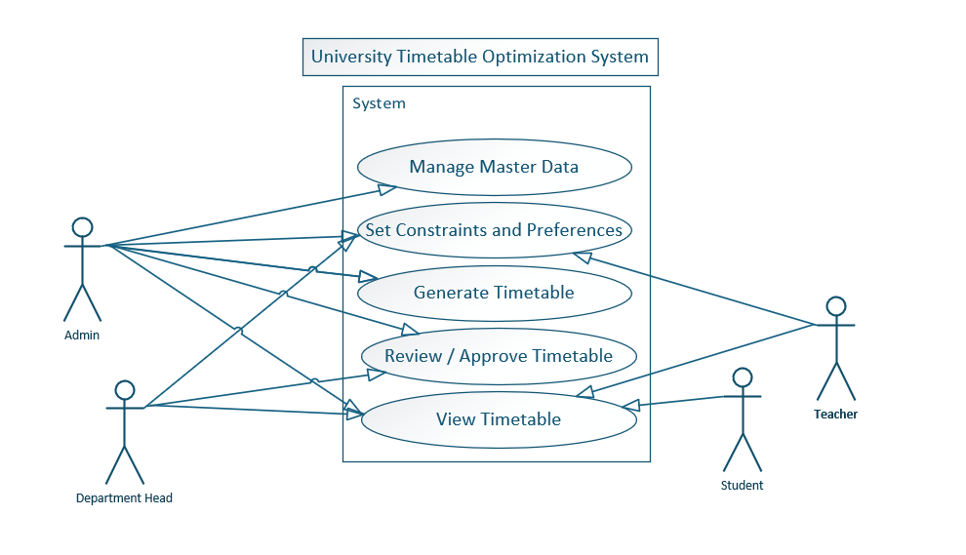
Diagram 2 — System Sequence Diagram (pick one use case — do UC-02: Generate Timetable) Shows the back-and-forth messages between the user and the system for one scenario, in time order (top to bottom).
- Left column: Admin (stick figure)
- Right column: System (box)
- Arrows left→right = Admin sends something (e.g. "clicks Generate")
- Arrows right→left = System responds (e.g. "shows progress indicator")
- Draw it step by step matching the Main Flow you already wrote in UC-02
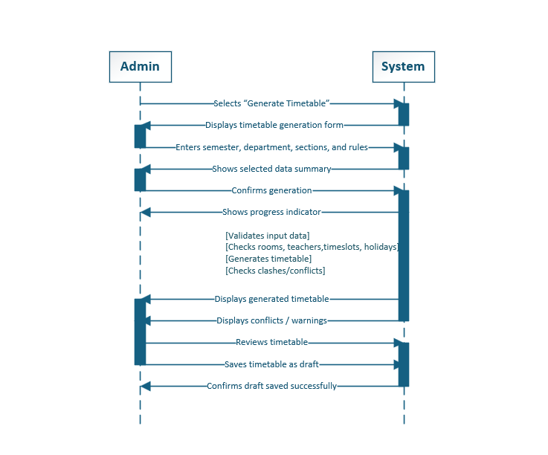
Diagram 3 — Architecture Diagram Shows the four components and how data flows between them.
- Four boxes: Frontend, Backend API, Database, Solver Engine
- Arrows between them with labels: "HTTPS/REST", "SQL queries", "Problem model", "Assignment result"
- You already have the ASCII version in the document — just draw it as proper boxes
